**Credit Task 2.3**

**Significant Contribution to the Team in Sprint 1**

In this report, I will demonstrate that I have made a good contribution to the development team in Sprint #1. Therefore, all team members could successfully complete the specified requirements before moving to the next sprint.

In details, one of our team members, The Anh Hoang, did not study Development Project 1; therefore, he had no idea when trying to get familiar with the development tools, especially Github and Trello.

The other team member, Huy Phung, was not confident with version control tools. He found it difficult to manage the source code when using Github command line.

I realized that it would not be a good idea for the team to spend too much time to learn how to use Github again.

The team must focus on the learning outcomes of this unit as well as the Sprint’s requirement. Therefore, I briefly wrote a Github “cheatsheet” for my team and explained the steps when using this tool. The evidence is shown below.

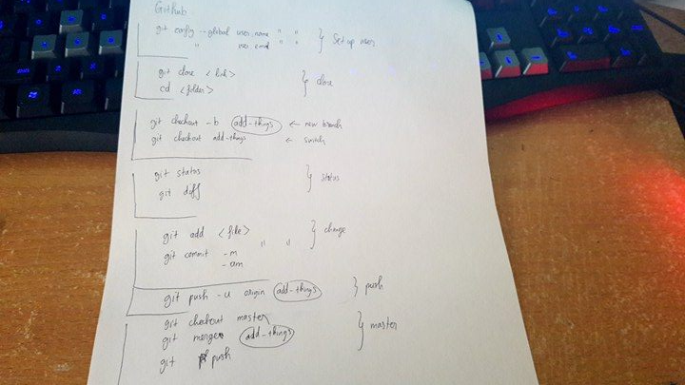

Moreover, based on my experience in DP1, I also wrote down some notes of things the team need to take notice of.

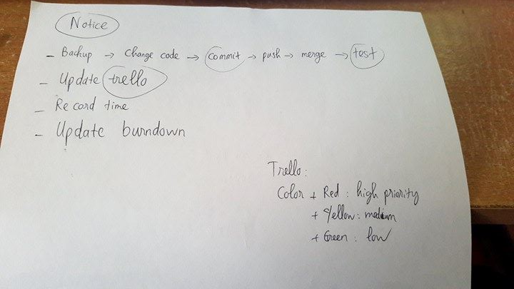

When we were working on Sprint #1, a problem was found when we worked with Github. All members worked on our given backlog tasks and uploaded the code to the cloud daily. However, on the first three days, the graph only showed the contributions of Huy (aerospace666) and me (tnn112710) as shown below.

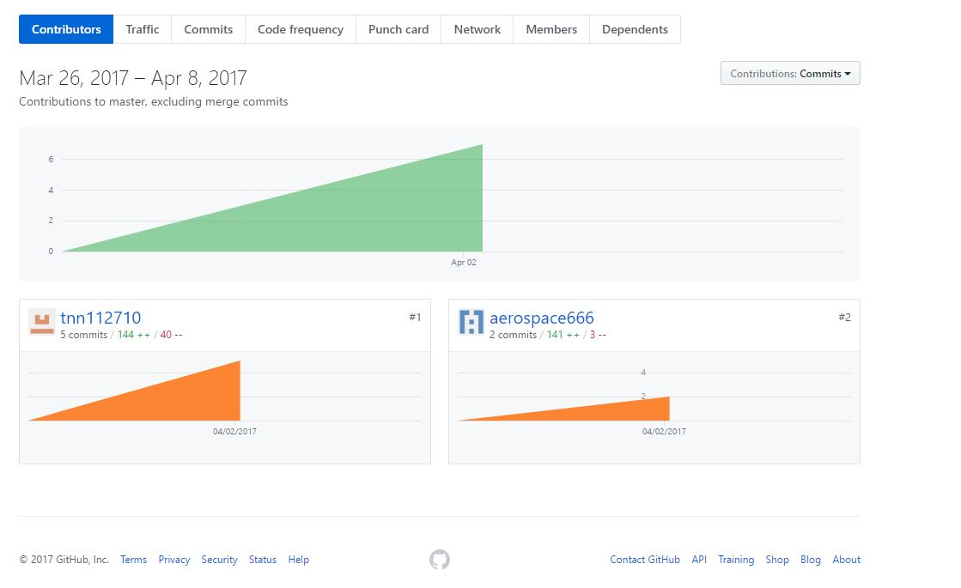

After spending a while inspecting the problem, I found that The Anh configured his username correctly but the email was wrong. His email should be @gmail.com instead of @outlook.com. Therefore, although we could see his commits, the graph did not show him as a contributor.

TEAM MEMBERS SIGNATURES:

Nhan Huy Anh